Case 9-MEX-Michoacan-Male-Feather Headdress-Necklace-Ear Spools-Terra cotta-500 BCE

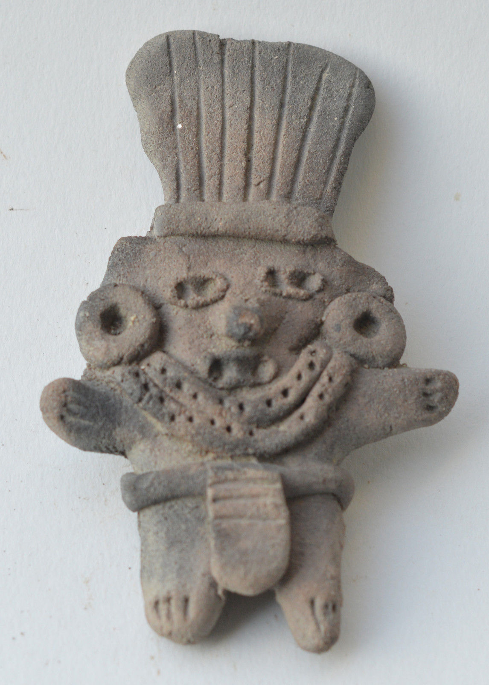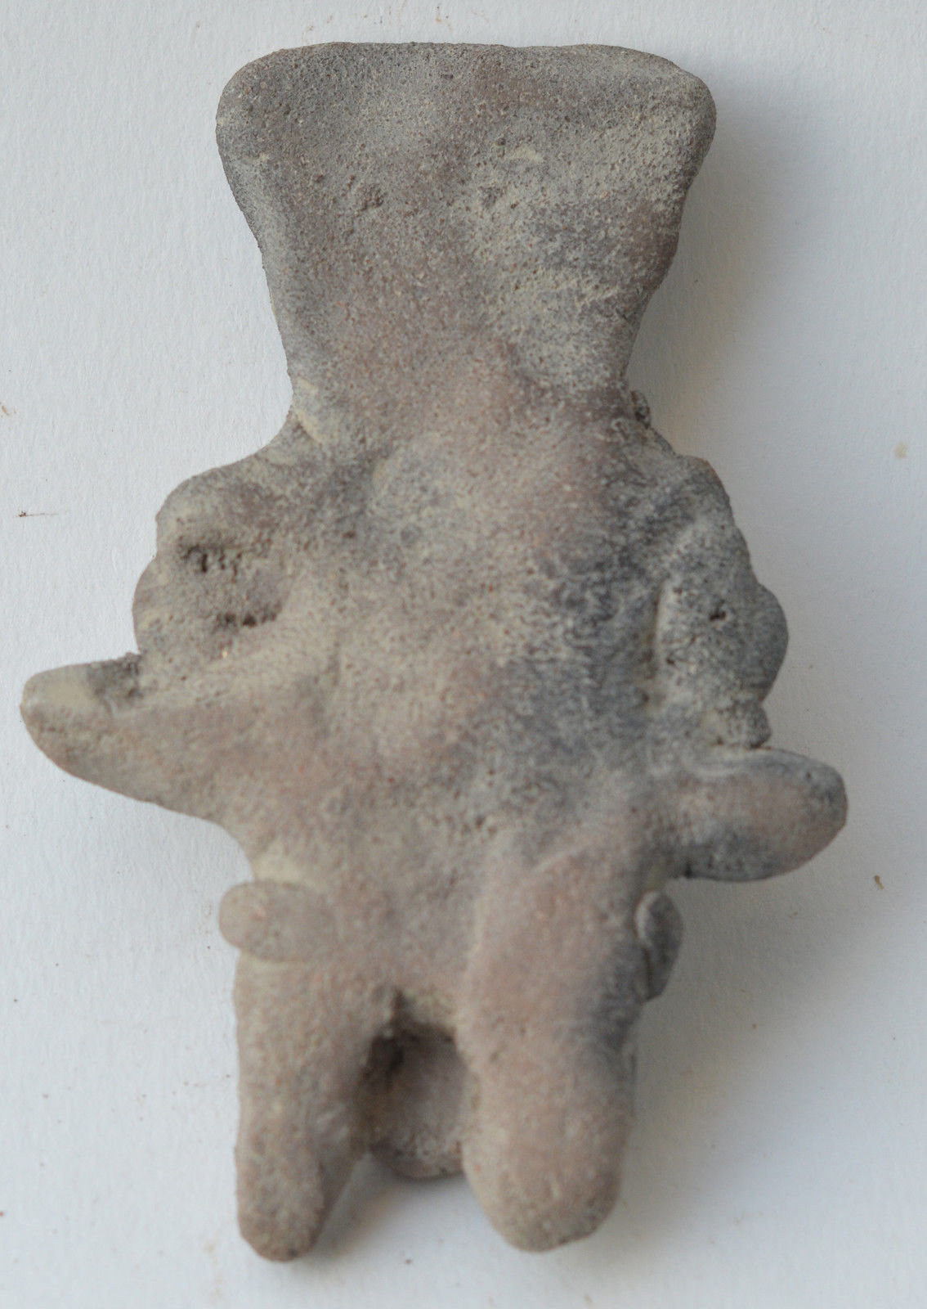
MEX-Michoacan-Male-Feather Headdress-Necklace-Ear Spools-Terra cotta-500 BCE
Case No.:
Formal Label: MEX-Michoacan-Male-Feather Headdress-Necklace-Ear Spools-Terra cotta-500 BCE
Accession Number:
Display Description:
“Michoacán” is derived from the Nahuatl “michhuah” ("fishermen") and -cān (place of) on Lake Chapala. In the pre-Hispanic period, there were waves of migration into the area, including the Pirinda, Nahua, Huetamo, Colima. There are sites of formal settlements from all Mesoamerican periods. Important sites include El Opeño and those in Curutarán, Tepalcatepec, Apatzingán, Zinapécuaro and Coalcomán. The territory has been inhabited by the Nahua, Otomi, Matlatzinca, Pirinda and Teco peoples (UMSNH. 2011).
LC No.: F1219.A1
Date or Time Horizon: 500 BCE
Geographical Area: Mexico
Map:
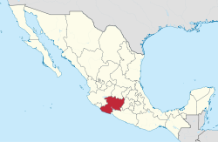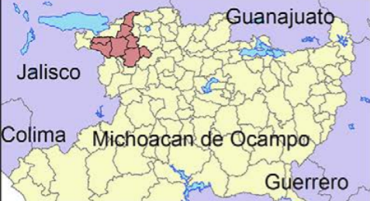
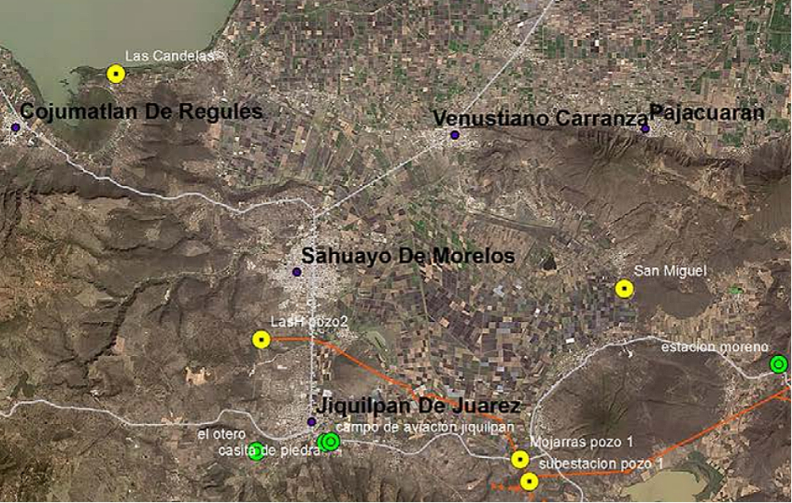
Figure . Location of archaeological sites (green, reported; yellow, registered) northwestern Michoacán bordering on Lake Chapala; map by David Muñiz.

Cultural Affiliation: Michoacan
Medium: Terracotta
Dimensions: 9 cm
Weight:
Provenance: Netherlands collection
Discussion:
References:
UMSNH. 2011. El Estado de Michoacán Epoca Prehispanica" [The State of Michoacan, Pre-Hispanic Era]. Morelia, Michoacán: UMSNH.

